



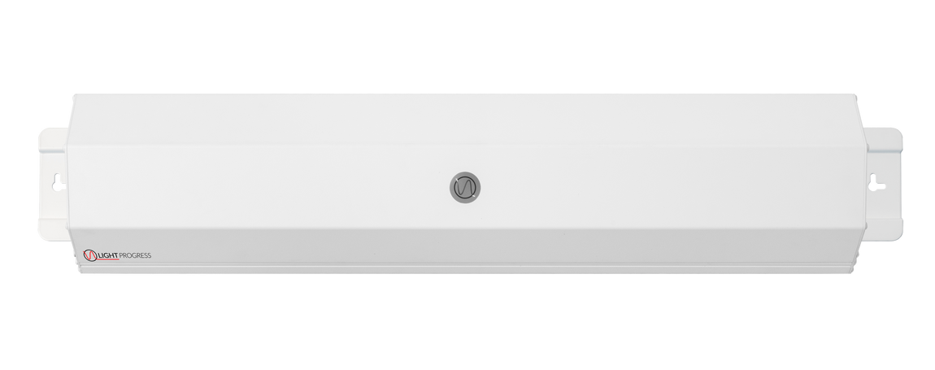
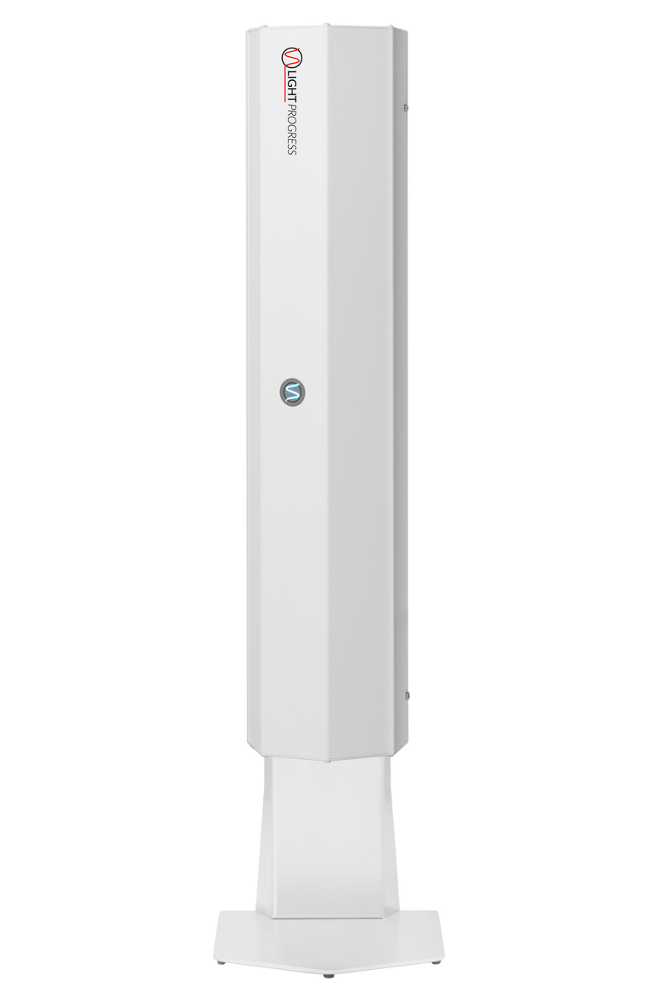
WE ARE THE AIR WE BREATHE

PRODUCT SPECSHEET
UV-FAN-XS
The UV FAN series is a range of professional air purifiers with fans, that guarantees microbial reduction percentage rates, up to 99.99% for each passage of air inside the device, tested by Independent Laboratories.

The air can be purified 24 hours per day in presence of people, thus guaranteeing people’s complete protection against airborne pathogens, including bird flu H5N1, SARS, Sars-Cov-2, Herpes, Legionella Pneumophila, TBC, but also Bacteria, Yeasts, Moulds, and Fungi.

Different versions available, for a perfect fit in any room.
KEY PRODUCT FEATURES
UV-C germicidal chamber shielded inside the device, to maximize air treatment and safely use the device in presence of people.
Silent built-in fan, for use in all working and educational contexts. Radio Control (optional) to turn on/off the device.
Inspection porthole in polycarbonate resistant to UV-C, to safely check the lamps in operation. 99,97% reduction of SARS-COV-2, tested and certified by Specialized and Independent lab.
Increased Disinfection Performance, with High-Output UV-C lamps (253,7 nm) and internal mirror bright aluminum reflector.
“Smart” connectivity (optional, with smart plug), to integrate the device and control it remotely with any compatible mobile App for smartphone and tablet.
Low costs solution for both energy consumption and maintenance, to be used in combination with natural ventilation

UV-FAN-XS

UV-FAN-XS
+ STAND-XS

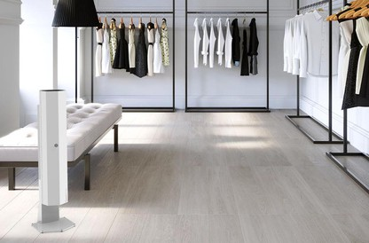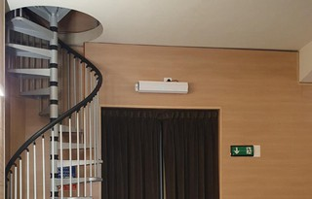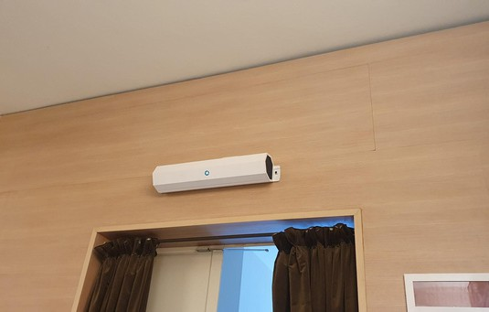

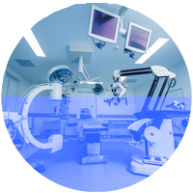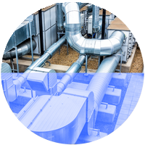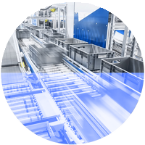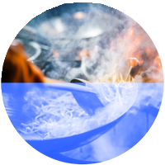

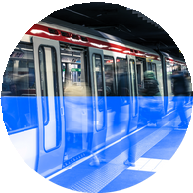
HEALTHCARE HVAC PROCESS INDUSTRY
HOSPITALITY SHARED SPACES
PUBLIC VENUES
WELLNESS CENTRES
TRANSPORT

TECHNICAL TABLE
* Continuous operation
GHP-60WH 60W
mm 690 x 157 x 168
(in 27.16 x 6.18 x 6.61)
kg 4,5
(lb 9.92)
36 dB
m³/h 70
(CF/M 41.16)
mm 220 x 232 x h756
(in 8.66 x 9.13 x h.29.76)
FOR ALL MODELS
≤ 18.000
IP 20
MIN. -15°C ÷ MAX. +40°C | (MIN. 5.0°F ÷ MAX. +104.0°F)
From 20 to max. 90% 230V or 110-277V | 50/60 Hz
Power supply cable (3x1mm²) length 2m, with IEC socket and plug (SCHUKO/others)
LAMP LIFE (hours)* PROTECTION RATING OP. TEMPERATURE**
OP. RELATIVE HUMIDITY** VAC | FREQUENCY
ELECTRICAL CONNECTION
** Outside of these ranges, performance may not be optimal




TROUBLE-FREE INTEGRATION AND INSTALLATION
Mounting and powering the device can be done without complex requirements. Ongoing maintanance only takes a few minutes to replace lamps when necessary.

TECHNICAL DRAWINGS
Every Light Progress Product is available in detailed DWG and STEP files for your design-in and specification clarity.
VIEW or DOWNLOAD now

CLICK HERE

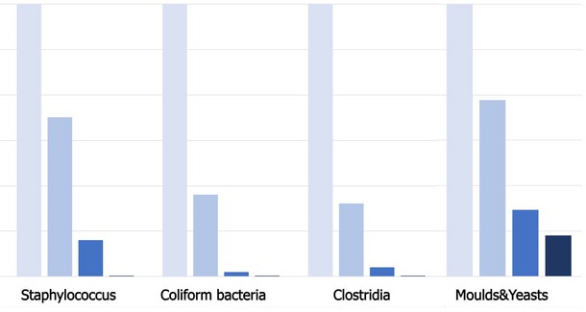
MICROBIAL TESTS AND EFFICACY
Microbial load in the air
99,97% reduction of SARS-COV-2 virus, tested and certified by Specialized Labs.

Light Progress customers rely on our extensive history of third party testing and proven efficacy to meet any level of disinfection validated against literally any virus or microorganism.
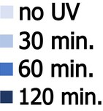



We understand your need to meet Regulatory Requirements and Industrial Standards as we help you achieve microbial load reduction using our UV systems.

Light Progress Group SRL Anghiari (AR)
ITALIA
REV25_01
© Light Progress s.r.l. - All rights reserved

Light Progress GmbH Aschaffenburg (BY) DEUTSCHLAND

Light Progress LLC Dallas, (TX)
USA

OFFICIALLY DISTRIBUTED BY:

UV-FAN-XS-60HP
Basic
UV-FAN-XS-60HP-RC
with radio control
FEATURES REPLACEMENT LAMP POWER CONSUMPTION
DIMENSIONS (WxHxD)

WEIGHT NOISE LEVEL
AIR VOLUME TREATED

OPTIONAL: FLOOR STAND
-COD. STAND-XS

